**SHAD0W SENSE ALARM**

ABSTRACT:

Our mini project is to design and check the functionality of 'SHADOW SENSE ALARM' circuit.It can detect the movement of any person near it and triggers the alarm.It can be used at night by shopkeepers to protect the valuables in their showrooms.It can also used provide security at warehouses(go-downs)where storage and protection of various types of goods in main concern, and works good for home-secuirty too.A dim lighting in the room is necessary to detect the moving shadow . Unlike opto-interruption alarms based on light-dependent resistors(LDR),its does not require an aligned light beam to illuminate the photo -sensor

Aim:

Our aim is to sense the shadow and it can be indicated by alarm with the help of IC UA741.

Apparatus Required:

|  |  |  |  |
| --- | --- | --- | --- |
| S.no | Apparatus Name | Range | Qutantity |
| 1. | Op amp | IC741 | 1 |
| 2. | Transistor | BC557 | 1 |
| 3. | Resistor | 10k,1kohm | 3,1 |
| 4. | LED | - | 1 |
| 5. | LDR | - | 1 |
| 6. | Buzzer | - | 1 |
| 7. | Battery | 9V | 1 |
| 8. | Bread board | - | 1 |
| 9. | Connecting wires | - | 1 |

Working:

op amp IC UA 741 is used as voltage comparator.Its inverting input pin2 recevices half supply voltage through the potential resistors R1and R2.The non inverting input pin3 gets a variable voltage through LDRand VR.Normally when the LDR gets light,its resistance will be low and its conducts and provide a high voltage to the non inverting input of IC.This makes the output of IC high.The high output formIC is given to the base of T1 through a current limiting resistor R3.T1 is PNP transistor and it conducts only when its base becomes negative.SoT1 remains off and buzzer and LED connected to its emitter remains off. when a person passes infront LDR, the shadow of the person reduces the resistance of LDR voltage at the non inverting input of IC decreases.This makes the output of IC low.Immediatly T1 conducts activating Buzzer and LED indicating the entry of a person

Procedure:

1.Connections are given as per the circuit diagram.

2.When someone's shadow falls on the LDR the resistance increases and a low voltage passes through the base making the collector of the transistor to conduct .

3.And this make the light to blink and buzzer tends on.

4.This circuit is highly sensitive and can detect the shadow of moving person from a distance of 1 meter.

Circuit diagram:

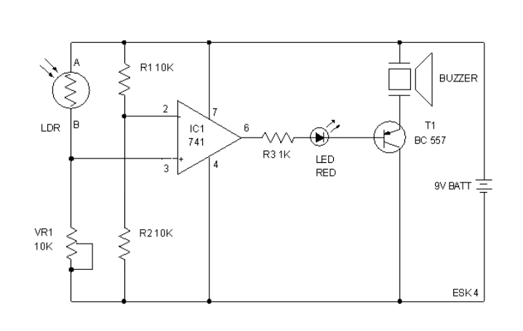

Output 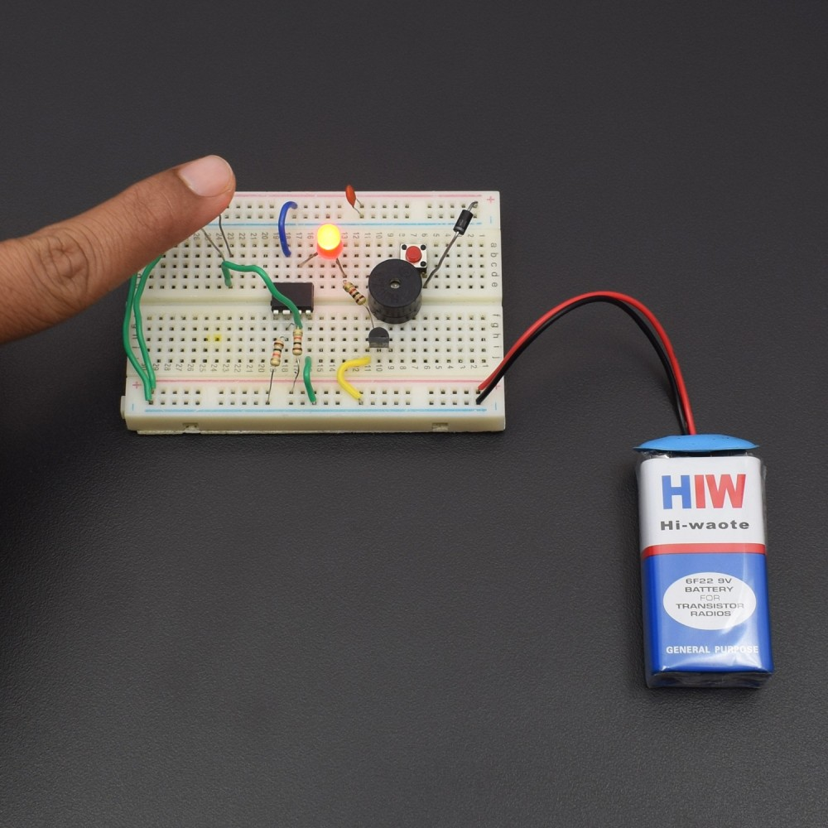

Result

With the help of IC UA 741 the shadow was detected.